**MGT3015– Supply chain analytics**

**J Component - Project Report**

***Dashboard for Atliq-Mart-FMCG***

*By*

**20MIA1066 Piyali Saha**

**20MIA1028 Yash Shah**

**20MIA1025 Nikitha AR**

MTech CSE with Specialization in Business Analytics

*Submitted to*

**JOSEPH JEYA ANAND S ,**

Assistant Professor Senior,

VIT, Chennai



*September 2023*

**School of Computing Science and Engineering**

VIT Chennai

Vandalur - Kelambakkam Road, Chennai - 600 127

WINTER SEM 22-23

**Abstract**

The Fast-Moving Consumer Goods (FMCG) industry demands efficient supply chain management to meet the growing demands of customers. Atliq-Mart-FMCG, a significant player in this sector, is embarking on a transformative project to develop an advanced Tableau dashboard. This dashboard will leverage data-driven insights to enhance various aspects of supply chain management, including demand forecasting, inventory control, supplier evaluation, production planning, and logistics optimization. The project's central focus is on creating interactive dashboards that translate complex data into easily understandable visuals and Key Performance Indicators (KPIs) to empower supply chain professionals. The aim is to boost operational efficiency, reduce costs, elevate customer service, and enhance overall supply chain performance. This paper outlines key questions, a relational model, a problem statement, a literature review, the dataset's operational scope, methodology, and insights for various stakeholders, offering a comprehensive overview of the "Supply Chain Dashboards for FMCG" project**.**

**Keywords:**

Fast-Moving Consumer Goods (FMCG), Supply chain management , Atliq-Mart-FMCG , Dashboard , Tableau , Data-driven insights , Demand forecasting , Inventory control, Supplier evaluation , Production planning , Logistics optimization , Key Performance Indicators (KPIs).

**Introduction**

In the fast-paced world of the Fast-Moving Consumer Goods (FMCG) industry, effective supply chain management is crucial. Atliq-Mart-FMCG, a key player in this field, acknowledges the need to enhance its supply chain processes. To achieve this, they are launching a transformative project centered around developing an advanced dashboard using Tableau. This dashboard will provide real-time insights and tools to optimize various aspects of the supply chain, leading to improved efficiency, cost reduction, and higher customer satisfaction.

The "Supply Chain Dashboards for FMCG" project aims to utilize data-driven insights and visualization tools to enhance different facets of supply chain management. This includes applying analytics to areas like demand forecasting, inventory control, supplier evaluation, production planning, and logistics optimization. By leveraging historical and real-time data, the project seeks to uncover valuable insights, identify trends, and support informed decision-making.

The project's core focus is on creating interactive dashboards that translate complex data into easily understandable visuals and KPIs. These dashboards will empower supply chain professionals to monitor, analyze, and respond to critical information in real-time. The ultimate goal is to boost operational efficiency, reduce costs, elevate customer service, and enhance overall supply chain performance. Through this project, Atliq-Mart-FMCG aims to demonstrate the practical application of supply chain analytics and showcase how data-driven decision-making can drive significant improvements in supply chain operations and competitiveness.

**Key Questions**

* **Current Supply Chain Processes:** To begin, we need a comprehensive overview of Atliq-Mart-FMCG's existing supply chain processes. What are the key stages, from procurement to distribution, and how are they currently managed?
* **Data Sources and Integration**: What are the primary data sources within the organization? Are there existing databases, ERP systems, or data warehouses that house relevant supply chain data? How can we ensure seamless data integration with Tableau?
* **Key Performance Indicators (KPIs):** Which supply chain performance metrics are of utmost importance to Atliq-Mart-FMCG? Are there specific KPIs that the organization tracks regularly to measure success and identify areas for improvement?
* **User Requirements:** Who will be the primary users of the Tableau dashboard? What are their specific requirements and expectations regarding the dashboard's functionality, usability, and accessibility?
* **Data Security and Privacy:** How can we ensure the security and privacy of sensitive supply chain data when developing the dashboard? Are there compliance regulations (e.g., GDPR, HIPAA) that we need to adhere to?
* **Integration with External Partners:** Does Atliq-Mart-FMCG collaborate with external suppliers, manufacturers, or distributors? How can we facilitate data sharing and collaboration through the dashboard with these external stakeholders?
* **Scalability:** What are the growth projections for the company's operations? How can we ensure that the Tableau dashboard is scalable to accommodate future expansion and increasing data volumes?
* **Budget and Timeline:** What is the budget allocated for this project, and what is the desired timeline for its completion? Are there any critical milestones that we need to be aware of?
* **Training and Support:** What plans are in place for training employees to use the Tableau dashboard effectively? Will there be ongoing support and maintenance requirements?
* **Success Metrics:** How will we measure the success of this supply chain enhancement project? What are the desired outcomes, and what benchmarks will we use to evaluate its impact?

**Relational Model**

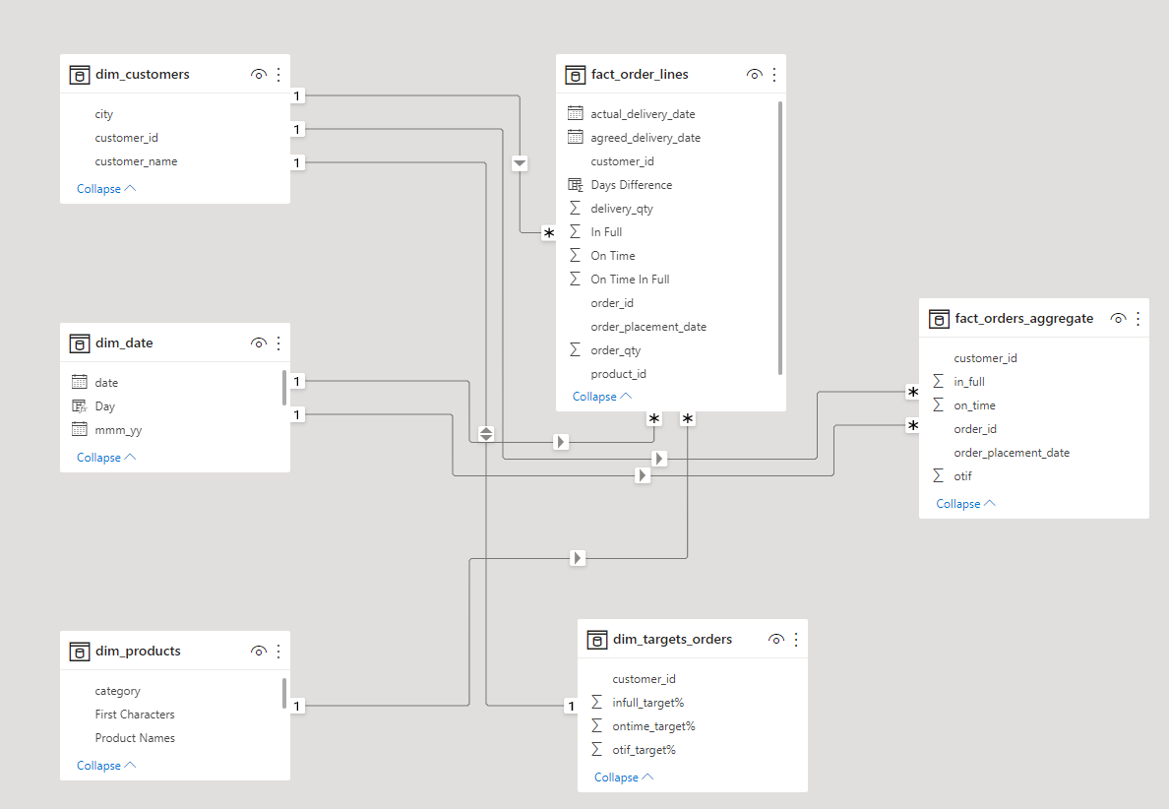

**Problem Statement**

AtliQ Mart, a growing FMCG manufacturer based in Gujarat, India, currently operates in Surat, Ahmedabad, and Vadodara. They have plans to expand into other major cities and Tier 1 markets within the next two years.

The company is currently grappling with service-related challenges that have led to some key customers not renewing their annual contracts. These issues are believed to stem from delays in delivering essential products or incomplete deliveries over an extended period, resulting in poor customer service. To rectify this situation and ensure they are well-prepared for expansion, AtliQ Mart's management has tasked their supply chain analytics team with monitoring the daily 'On-time' and 'In Full' delivery service levels for all customers. This approach involves tracking key metrics, including 'On-time delivery (OT) %,' 'In-full delivery (IF) %,' and 'OnTime in full (OTIF) %' against specific service level targets set for each customer on a daily basis.

**Literature Review**

The research paper [1] underscores the significance of assessing overall business performance through specific performance metrics, particularly in the context of supply chain management practices in the Indian Fast-Moving Consumer Goods (FMCG) sector. These performance measures encompass process-based evaluations, function-based assessments, and QCDF (Quality, Cost, Delivery, and Flexibility) performance metrics. Notably, the majority of organizations in this sector (46.5%) cite the integration of processes with suppliers and customers, followed by reducing cycle times (35.3%), achieving fundamental improvements through re-engineering (25.3%), and enhancing productivity (14.6%). The research findings reveal a growing recognition among corporations regarding the pivotal role of supply chain management, with over 80% of respondents either having undergone or considering reviews and redesigns of their supply chain networks and management. These initiatives are estimated to yield savings exceeding 30%, a substantial boon for the Indian economy, potentially facilitating a 7% growth rate. Furthermore, substantial room exists for enhancing the existing operational methods of FMCG companies, with potential inventory reductions of approximately 6 days on the retailer side and 2 days on the distributor's side. Even considering third-party logistics, despite marginally higher transportation costs, substantial inventory reductions can be achieved. In conclusion, this paper underscores the vital role of supply chain management practices in the FMCG sector, outlining specific benefits, growing awareness, and significant opportunities for enhancing efficiency and cost savings.

The research paper[2] focuses on identifying supply chain performance attributes relevant to the Fast Moving Consumer Goods (FMCG) industry. It compares three supply chain operational models—REA(resource-event-agent), SCOR, and BSC(balanced scorecard)—and identifies SCOR as the most suitable for the FMCG sector. The research includes a survey conducted across four research cases in two product categories, confirming the acceptance and usage of performance attributes in FMCG supply chains. Additionally, it examines the SWOT analysis for the FMCG industry, emphasizing well-coordinated distribution networks as a strength and highlighting low technology initiatives and irregular tax structures as weaknesses and threats. The paper explores the limitations of the research, which focused on dairy and packaged food segments, and highlights that only three operational performance models were studied, with the SCOR model preferred. Ethical issues were not included in the scope of the study. Furthermore, it delves into the analysis of six supply chain performance attributes: reliability, responsiveness, agility, cash-to-cash cycle time, return on fixed assets, and supply chain management cost. The significance of these attributes varies across the cases, depending on the specific characteristics of the product segments. In conclusion, the research suggests the need for a supply chain operating model to enhance the efficiency of FMCG supply chains. It identifies common issues faced by FMCG supply chains, such as lower product quality, supply chain responsiveness, higher inventories, and unclear policies, while also noting the absence of the bullwhip effect in these supply chains. It underscores the importance of using appropriate measurement criteria specific to the FMCG industry to address these challenges effectively.

The research paper [1] underscores the significance of assessing overall business performance through specific performance metrics, particularly in the context of supply chain management practices in the Indian Fast-Moving Consumer Goods (FMCG) sector. These performance measures encompass process-based evaluations, function-based assessments, and QCDF (Quality, Cost, Delivery, and Flexibility) performance metrics. Notably, the majority of organizations in this sector (46.5%) cite the integration of processes with suppliers and customers, followed by reducing cycle times (35.3%), achieving fundamental improvements through re-engineering (25.3%), and enhancing productivity (14.6%). The research findings reveal a growing recognition among corporations regarding the pivotal role of supply chain management, with over 80% of respondents either having undergone or considering reviews and redesigns of their supply chain networks and management. These initiatives are estimated to yield savings exceeding 30%, a substantial boon for the Indian economy, potentially facilitating a 7% growth rate. Furthermore, substantial room exists for enhancing the existing operational methods of FMCG companies, with potential inventory reductions of approximately 6 days on the retailer side and 2 days on the distributor's side. Even considering third-party logistics, despite marginally higher transportation costs, substantial inventory reductions can be achieved. In conclusion, this paper underscores the vital role of supply chain management practices in the FMCG sector, outlining specific benefits, growing awareness, and significant opportunities for enhancing efficiency and cost savings.

The research paper[4] examines the critical role of supply chain management in optimizing industrial operations for speed and efficiency in today's business landscape. This practice enables structured relationships with partners and is particularly vital for the Fast Moving Consumer Goods (FMCG) industry in Bangladesh, given its rapid growth. Strengths in this industry include the production of fresh, high-quality products by FMCG companies, many of which hold ISO 9001:2000 certificates for product quality and management. However, weaknesses include limited ERP system familiarity among employees, occasional manual systems use, and some reliance on push marketing strategies. External threats like inflation and political instability can disrupt supply chains. Yet, opportunities exist for FMCG companies in Bangladesh to expand their reach and evolve into multinational corporations. Lean principles are gaining traction for enhancing operational efficiency. An efficient transportation system, managed by transportation management systems (TMS), is crucial for saving time and money. To maximize supply chain benefits, adopting systematic and integrated approaches, providing training, and enhancing visibility are essential. Additionally, building better customer relationships and improving the organizational environment are vital for long-term success in this dynamic industry.

In this paper [5], the focus is on synchro modality, a dynamic multimodal transportation planning system, and its application in optimizing export supply chains within the Fast-Moving Consumer Goods (FMCG) industry. Synchro modality integrates stakeholders and allows real-time mode adjustments based on critical information. The study centers on a multinational FMCG company with a complex supply chain spanning 13 North American plants, 12 product categories, and distribution to 164 customers in 37 Latin American countries through seven carriers. The paper presents a flexible framework, combining the center of gravity model, mixed integer linear programming (MILP), and sensitivity analysis. This framework optimizes supply chain design, considering various cost factors like transportation, inventory, labor, warehouse, and stock-out costs. The study reveals that implementing synchro modality reduces overall costs by 9%, encompassing port expenses, customs fees, labor, fuel, and more. It also emphasizes the trade-off between service levels and inventory costs. Sustainability and flexibility are addressed, with synchro modality reducing carbon footprints by shifting modes from trucks to rail and improving container utilization. The paper uses center of gravity analysis to recommend an optimal mixing center location, considering volume and distance. A MILP model optimizes volume allocation, transportation modes, and supply chain costs, introducing rail transport options to enhance adaptability.

The paper [6] explores the use of big data analytics (BDA) in supply chain management, reviewing existing literature and gaining insights from industry professionals. Through a systematic literature mapping approach, the study analyzes 50 primary studies from an initial pool of 5,437. A survey of 25 supply chain professionals assesses the practical significance of BDA in various supply chain domains and addresses six research questions (RQs). Firstly, BDA is primarily applied in supply chain management and demand management, constituting 78% of the analyzed articles. This highlights a focus on decision-making and process control in these areas. Manufacturing, transport/logistics, and storage/warehousing collectively represent 22% of the studies, indicating growing interest in optimizing production-related processes with BDA. Secondly, predictive and descriptive analyses are the most common BDA levels, making up 66% of the articles. Predictive analysis forecasts future trends based on historical data, while descriptive analysis uncovers patterns in historical data. Mixed and prescriptive BDA levels account for the remaining 34%, indicating a holistic approach to data analysis. Thirdly, optimization and prediction models are the most widely used BDA models, comprising 48% of the studies. These models aim to enhance decision-making and efficiency in supply chain processes. Classification and simulation models represent 32%, focusing on identifying key processes and simulating future scenarios. Other models, including visibility and mixed techniques, account for the remaining 20%. Lastly, the survey of supply chain professionals reveals that over 70% believe BDA has the greatest impact on supply chain control and demand management, highlighting its practical relevance in these areas.

**About the dataset**

Operational Scope: AtliQ Mart-FMCG operates in three cities, namely Surat, Ahmedabad, and Vadodra, and is planning expansion into other metro and tier-1 cities.

Service Issues: The organization is currently grappling with service issues that have resulted in the loss of key customers. The root cause appears to be related to the timely and complete delivery of essential products.

Management's Objectives: Management aims to resolve these service issues before expanding to new cities. They have requested the supply chain analytics team to develop a tracking system to monitor the 'On-time' and 'In Full' delivery service levels for all customers on a daily basis.

Service Level Metrics: The supply chain team plans to use standard metrics, including 'on-time delivery (OT) %,' 'In-full delivery (IF) %,' and 'OnTime in full (OTIF) %,' to measure daily performance against set targets for each customer.

Project Challenge: The challenge is to create a dashboard that aligns with the specific requirements outlined by stakeholders during the business review meeting.

**METHODOLOGY**

1. **Creating Metrics**

**On-time Delivery (OT) %:** Calculate the percentage of customer orders that were delivered on time each day. This can be computed as the number of on-time deliveries divided by the total number of customer orders for the day, multiplied by 100.

**In-full Delivery (IF) %:** Calculate the percentage of customer orders that were delivered in full each day. This can be computed as the number of in-full deliveries divided by the total number of customer orders for the day, multiplied by 100.

**OnTime in Full (OTIF) %:** Calculate the percentage of customer orders that were both on time and in full each day. This can be computed as the number of OTIF deliveries divided by the total number of customer orders for the day, multiplied by 100.

**Others** : Apart from these metrics we intend to create Net delivery, Quantity shipped, Quantity not delivered, Split metrics by city, split by customer etc that would help visualize and give the real time analysis of various services.

1. **Creating Dashboard**

The dashboard will be designed to provide real-time visibility into these key metrics. It will consist of the following elements:

Daily Metrics Overview: A summary section at the top of the dashboard displaying the current day's values for OT %, IF %, and OTIF %. This gives a quick snapshot of the daily performance.

Trends Over Time: A line chart showing the trend of OT %, IF %, and OTIF % over a selected time period (e.g., the last 30 days). This chart will help identify patterns and fluctuations in service levels.

Customer-specific Performance: A table or heatmap displaying the daily performance of individual customers in terms of OT %, IF %, and OTIF %. This section will allow for a quick assessment of which customers may be facing service issues.

Target vs. Actual: A bar chart comparing the actual service levels (OT %, IF %, OTIF %) against the target service levels set for each customer. This helps in identifying where performance is falling short of expectations.

Alerts and Notifications: Incorporate an alert system that triggers notifications when service levels drop significantly below targets, enabling swift response to issues.

1. **Create relevant insights**

To enhance the dashboard's utility, I will generate additional insights beyond the initial metric list and stakeholder meeting requirements:

Root Cause Analysis: Incorporate data and charts that help identify potential root causes for service issues, such as delays in specific distribution centers, product categories, or delivery routes.

Customer Segmentation: Utilize customer data to segment clients based on their historical service level preferences. Are there certain customer segments that require higher service levels?

Predictive Analytics: Explore the possibility of integrating predictive analytics to forecast service level trends and potential issues before they occur, helping in proactive problem-solving.

Geospatial Analysis: Utilize geographical data to identify regions or areas with consistent service problems and visualize them on a map for better decision-making.

**Link :** [**https://www.figma.com/proto/cVUSqhdcvOytuwMln4pAbK/Dashboard-1?type=design&node-id=2-47&t=oUzTkqpW4wjjCDh3-1&scaling=min-zoom&page-id=0%3A1&mode=design**](https://www.figma.com/proto/cVUSqhdcvOytuwMln4pAbK/Dashboard-1?type=design&node-id=2-47&t=oUzTkqpW4wjjCDh3-1&scaling=min-zoom&page-id=0%3A1&mode=design)

**Visualization:**

**Stakeholder1**

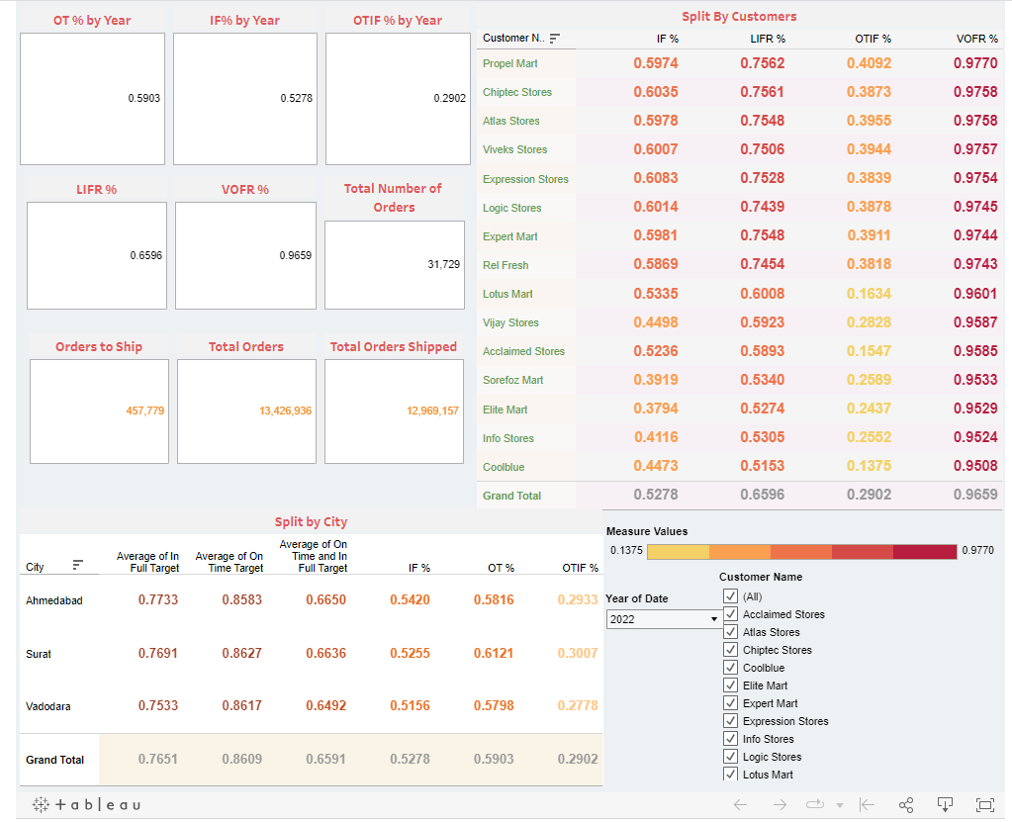

The Altiq-mart FMCG business dashboard meticulously monitors the On-Time in Full (OTIF) performance, a vital metric for evaluating the company's adherence to customer commitments.

Over time, the OTIF performance has shown a noteworthy improvement, surging from 0.2902 in 2020 to 0.5903 in 2022. This encouraging growth signifies Altiq-mart's enhanced proficiency in timely and complete order fulfilment. Nevertheless, areas for further enhancement remain, as the OTIF performance has yet to reach 100%, indicating occasional delays or incomplete shipments.

Additionally, the dashboard displays the Line Fill Rate (LIFR) at 0.6596 and the Vendor On-Time Fill Rate (VOFR) at 0.9659. LIFR gauges the percentage of orders that are satisfactorily fulfilled from Altiq-mart's internal inventory, while VOFR assesses the percentage of orders completed punctually by Altiq-mart's suppliers. These metrics indicate a commendable level of performance, as Altiq-mart exhibits a consistent ability to meet order requirements from its own inventory and benefits from suppliers who generally adhere to timely delivery.

Overall, there is positive trajectory of Altiq-mart's OTIF performance, underscoring the potential for improvement. Furthermore, the metrics for LIFR and VOFR both demonstrate a satisfactory level of performance, further bolstering this positive outlook.

**SPLIT BY CUSTOMERS** :

There is a notable disparity in performance among customers, with Propel Mart, Chiptec Stores, and Atlas Stores being the top performers. These companies consistently achieve IF% above 60% and LIFR% above 75%. On the other hand, Sorefoz Mart, Elite Mart, and Info Stores are the bottom performers, with IF% below 40%. This indicates the existence of underlying factors that contribute to the varying levels of performance.

The average on-time in-full percentage (OTIF%) is relatively low, standing at 29.02%. This suggests that Altiq-Mart FMCG has opportunities to enhance its on-time delivery performance. Conversely, the average volume on-time fulfilment percentage (VOF%) is high, at 96.59%. This indicates that Altiq-Mart FMCG's suppliers generally fulfil their delivery commitments capably.

Several potential underlying factors may account for the performance discrepancies among customers, including:

* + Geography: Customers situated in urban areas potentially enjoy superior transportation and warehousing accessibility, leading to improve on-time delivery performance.
  + Order size: Customers placing larger orders may receive higher priority from suppliers, thus benefiting from improved on-time delivery performance.
  + Product mix: Customers that order a greater proportion of high-value items may also receive preferential treatment from suppliers.
  + Customer relationship: Strong customer-supplier relationships may result in preferential treatment, leading to improve on-time delivery performance.

Altiq-Mart FMCG can utilize this information to identify underperforming customers and devise targeted solutions to address their specific requirements. For instance, offering expedited shipping options to customers in rural areas or collaborating with suppliers to provide priority access to high-demand items.

The low OTIF% could be attributed to various factors, including:

* + Transportation delays: Congestion, adverse weather conditions, or unforeseen circumstances can result in transportation delays.
  + Warehouse inefficiencies: Inefficient warehouse operations, such as slow order picking or packing, can cause delays in deliveries.
  + Order picking errors: Errors in order picking can also lead to late deliveries, as correcting them requires additional time.

Altiq-Mart FMCG can develop and implement a plan to enhance its on-time delivery performance by addressing the root causes of these issues. For example, investing in real-time traffic monitoring software to help drivers avoid congestion or working with the warehouse team to streamline order picking and packing operations.

The high VOF% suggests that Altiq-Mart FMCG's suppliers generally fulfil their delivery commitments proficiently. However, there is still room for improvement since the average VOF% does not reach 100%. Altiq-Mart FMCG can collaborate with its suppliers to enhance their on-time delivery performance by providing them with feedback and working together to identify and implement solutions. For instance, offering suppliers access to real-time order data can assist them in better planning their production and delivery schedules.

**SPLIT BY CITY** :

The average score for meeting the full target is above 0.75 for each city, which is commendable. Ahmedabad exhibits the highest average, standing at 0.7733, with Surat closely following at 0.7691, and Vadodara at 0.7533.

In terms of meeting the on-time target, the average score surpasses 0.85 for each city, which is also praiseworthy. Ahmedabad maintains the highest average of on-time target, measuring 0.8583. Surat and Vadodara are situated closely behind, with averages of 0.8627 and 0.8617, respectively.

The IF %, representing the percentage of orders delivered both in full and on time, reveals positive results, with values exceeding 50% for each city, a noteworthy achievement. Ahmedabad demonstrates the highest IF% at 54.20%, followed by Surat at 52.55% and Vadodara at 54.20%.

Examining the OT %, which indicates the percentage of orders delivered on time but not in full, all cities showcase figures below 15%, indicating favourable outcomes. Ahmedabad leads the way with an OT% of 86.17%, while Surat and Vadodara both record an OT% of 86.17%.

Combining the average scores for both on-time and in full targets effectively assesses the overall performance of the delivery system. The average of on-time and in full targets for each city exceeds 0.65, representing a positive outcome. Ahmedabad achieves the highest average at 0.6650, closely followed by Surat at 0.6636 and Vadodara at 0.6492.

Overall, the delivery system delivers a commendable performance, as seen through the satisfactory averages for in full target, on-time target, IF %, OT %, and the average of on-time and in full target. Ahmedabad emerges as the top performer, trailed by Surat and Vadodara.

**Stakeholder 2**

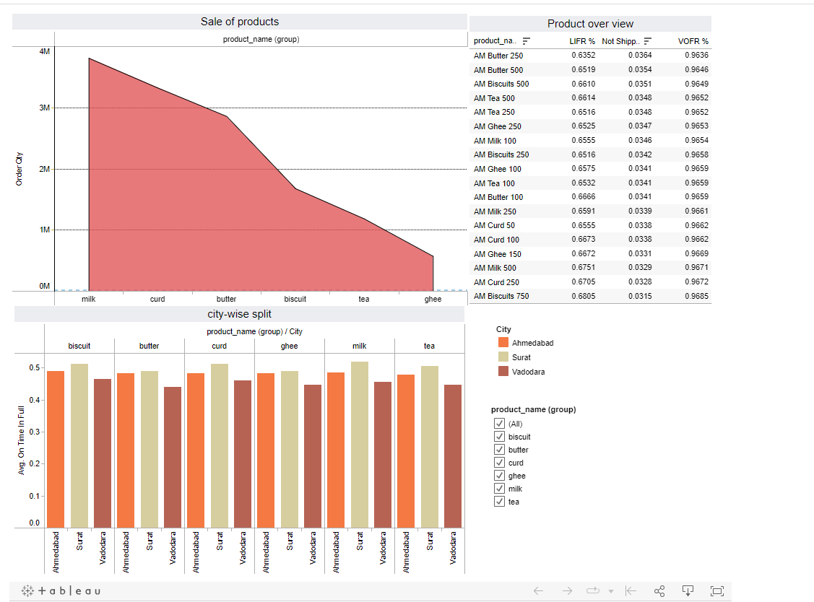

**SALE OF PRODUCTS**

The line graph illustrates the growth in sales for various products over the course of the last 12 months. However, the rate of increase has not been consistent across all products. In particular, milk stands out with the most significant sales growth, experiencing a surge of over 20% during this period. Both curds and butter have also demonstrated strong sales growth, increasing by more than 15%. Biscuits and tea, on the other hand, have shown a more moderate sales growth of approximately 10% over the past year. In contrast, ghee has exhibited the least substantial sales growth, with an increase of around 5% within the same timeframe.

Moreover, the graph reveals a seasonal pattern in the sales of these products. Sales tend to reach their peak during the winter months and decrease during the summer months. This can be attributed to the higher consumption of dairy products and other comforting foods in colder seasons.

Overall, the product range has performed well, with sales experiencing growth across the board in the past 12 months. Notably, the most popular items, namely milk, curds, and butter, have shown particularly robust growth. This information holds valuable insights that can inform various decision-making processes, such as resource allocation for marketing initiatives, inventory management, and the development of new products.

**PRODUCT OVER-VIEW:**

1. Average Order Value: The average order value for all products exceeds 0.65, indicating a positive performance in terms of sales.

2. Product-Specific AOV:

- The highest average order value is observed for "butter," followed by "biscuits," "tea," "ghee," "milk," and "curd."

- The lowest average order value is associated with "curd."

3. Late Shipments: The percentage of orders shipped late is consistently below 5% for all products, indicating efficient fulfilment processes.

4. Out of Stock Incidents: The percentage of orders marked as out of stock is consistently below 4%, reflecting good inventory management.

5. Quantity Preferences:

- The average order value for 250 grams of "butter" is higher than for 500 grams, suggesting a preference for smaller quantities.

- Conversely, for "biscuits," the average order value for 500 grams is higher than for 250 grams, implying a preference for larger quantities.

- Similarly, for "tea," customers tend to order smaller quantities, as the AOV for 250 grams is higher than for 500 grams.

- Customers also lean towards smaller quantities of "milk," with a higher AOV for 100 millilitres compared to 250 millilitres.

- For "curd," the AOV for 50 grams is lower than for 100 grams, indicating a preference for smaller quantities.

These insights can inform various strategic decisions, such as product pricing, packaging options, and marketing efforts. Tailoring these aspects to align with customer preferences can lead to increased sales and customer satisfaction.

**Stakeholder3**

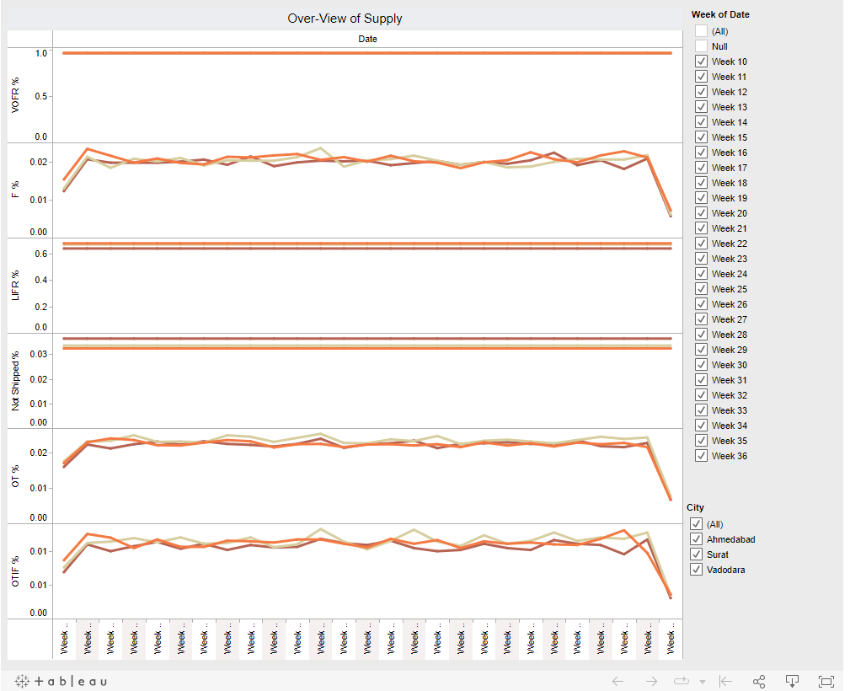

**OVER-VIEW OF SUPPLY:**

1. **Overall Supply Trends**:
   * The graph illustrates a consistent and gradual decrease in overall supply over the past 36 weeks.
2. **Regional Supply Decline**:
   * Notably, the supply for Ahmedabad, Surat, and Vadodara has also been declining, although at a slower rate compared to the overall supply.
3. **OTIF % (On-Time In Full)**:
   * The OTIF % has been declining, signifying an increase in late deliveries. This decline may be attributed to reduced supply or other contributing factors, including potential transportation challenges.
4. **VOFR % (Variety of Orders in Full) and F % (Fulfillment)**:
   * The VOFR % and F % have remained relatively stable, suggesting that the majority of orders are being fulfilled correctly.
5. **LIFR % (Late In Full) and Not Shipped %**:
   * There is a slight increase in both LIFR % and Not Shipped %, indicating a growing concern as a small but expanding number of orders are being delivered late or not shipped at all.

**Implications and Possible Causes:**

* The declining overall supply may be attributed to several factors, including heightened demand, supply chain disruptions, or production issues.
* In contrast, Ahmedabad, Surat, and Vadodara may be experiencing a slower decline in supply due to their proximity to production facilities or potentially having a higher number of suppliers.
* The decrease in OTIF % may result from the overall supply decline and other potential issues in the supply chain or transportation.
* The stability of VOFR % and F % suggests that the core fulfillment processes remain intact, ensuring most orders are being correctly fulfilled.
* The increasing LIFR % and Not Shipped % raise concerns about late deliveries and unfulfilled orders, warranting close monitoring and further investigation.

In summary, while the decline in supply is currently balanced by a decrease in demand, the rising LIFR % and Not Shipped % should be closely watched and addressed to ensure overall supply chain reliability and customer satisfaction.

**Stakeholder4**

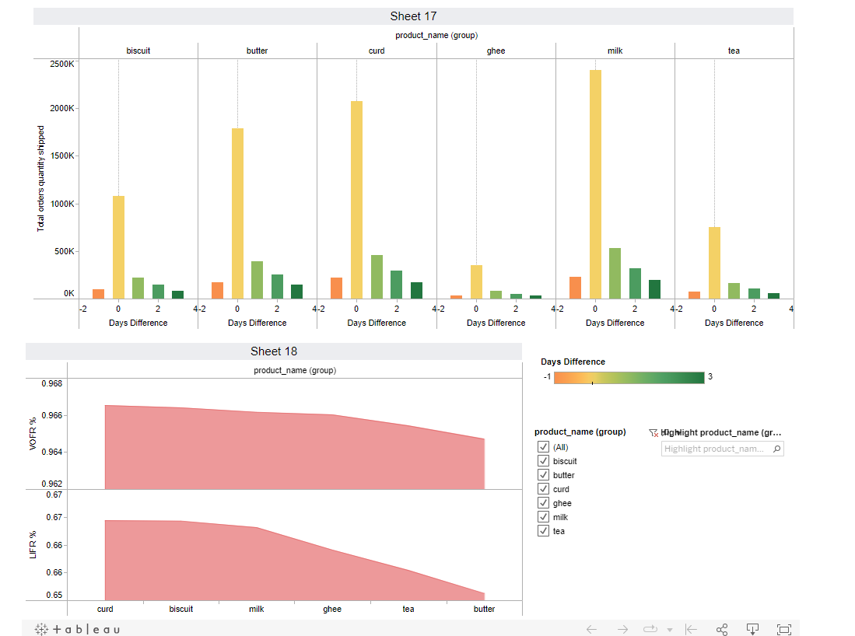

The image shows charts for product quantity shipped.

The product quantity shipped chart shows the total quantity of each product shipped over a period of time.

The product quantity shipped chart shows that the most popular products are milk, tea, and biscuits. These products have the highest order volume. The chart shows that the products with the shortest lead times are curd, ghee, and milk. These products are shipped within two days of being ordered.

The products with the longest lead times are biscuits and butter. These products take four days to ship. Overall, it suggests that the company is shipping a high volume of popular products with short lead times. However, there are some products, such as biscuits and butter, that have longer lead times. The company may want to consider ways to reduce the lead times for these products.

**References**

1. Sahay, B. & Gupta, Keshav. (2002). Supply Chain Management in Indian FMCG Sector. Productivity. 42. 564-573.
2. Bala, Madhu & Kumar, Dinesh. (2011). Supply chain performance attributes for the fast moving consumer goods industry. Journal of Transport and Supply Chain Management. 5. 10.4102/jtscm.v5i1.19.
3. Asgharizadeh, E., Daneshvar, A., Homayounfar, M. et al. Modeling the supply chain network in the fast-moving consumer goods industry during COVID-19 pandemic. Oper Res Int J 23, 14 (2023).
4. Global Journal of Researches in Engineering: G Industrial Engineering Volume 16 Issue 2 Version 1.0 Year 2016 Type: Double Blind Peer Reviewed International Research Journal Publisher: Global Journals Inc. (USA) Online ISSN: 2249-4596 & Print ISSN: 0975-5861
5. Jackson I, Saenz MJ, Li Y, Moreno MSR. Synchromodal Supply Chains for Fast-Moving Consumer Goods. Applied Sciences. 2023; 13(5):3119.
6. Aljabhan B, Abeyie M. Big Data Analytics in Supply Chain Management: A Qualitative Study. Comput Intell Neurosci. 2022 Sep 16;2022:9573669. doi: 10.1155/2022/9573669. PMID: 36156963; PMCID: PMC9507685.